**Entity Relationship Model(ER model)**

Entity-Relationship (ER) model is a visual representation of the table’s structure and the relationships between logically related tables.

In ER modeling the database structure is represented as a diagram known as ER diagram (ERD). An ER diagram gives a better understanding of the overall database structure. It becomes easier to map the tables, their keys, and relationships.

The ER diagram displays:

* Table structure along with the column names and their data types
* Primary and foreign key constraints
* Relationship between tables

Pre-requisite

* MS SQL Server
* SQL Server Management Studio (SSMS)

Create entities and relationships

To create an ER diagram; the tables must be logically related to one another with foreign key constraints.

Copy

--Use your database

USE HASURA;

GO

--1. Create 'COUNTRY' table

CREATE TABLE COUNTRY(

CountryId INT IDENTITY PRIMARY KEY, --auto-increment primary key

CountryName VARCHAR(30),

Continent VARCHAR(10),

Currency VARCHAR(3)

);

--2. Create 'DEPARTMENT' table

CREATE TABLE DEPARTMENT(

DepartmentId INT PRIMARY KEY,

DeptName VARCHAR(10),

CountryId INT FOREIGN KEY REFERENCES dbo.COUNTRY(CountryId),

);

--3. Create 'EMPLOYEE' table

CREATE TABLE EMPLOYEE(

EmpID INT PRIMARY KEY,

EmpName VARCHAR(20) NOT NULL,

DeptId INT FOREIGN KEY REFERENCES dbo.DEPARTMENT (DepartmentId) NULL

);

--4. Create 'FOLDER' table

CREATE TABLE FOLDER(

FolderId INT NOT NULL,

EmpId INT REFERENCES EMPLOYEE(EmpId),

AccessType VARCHAR(5) NULL

);

Create ER diagram in SSMS

* Open SQL Server Management Studio (SSMS).
* In the **Object Explorer** on the left, expand your database.
* Right-click on **Database Diagrams**, and then select **New Database Diagram**.

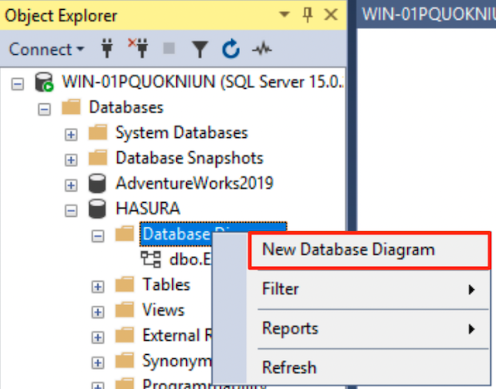

* Select the tables that you created above and then click **Add**.

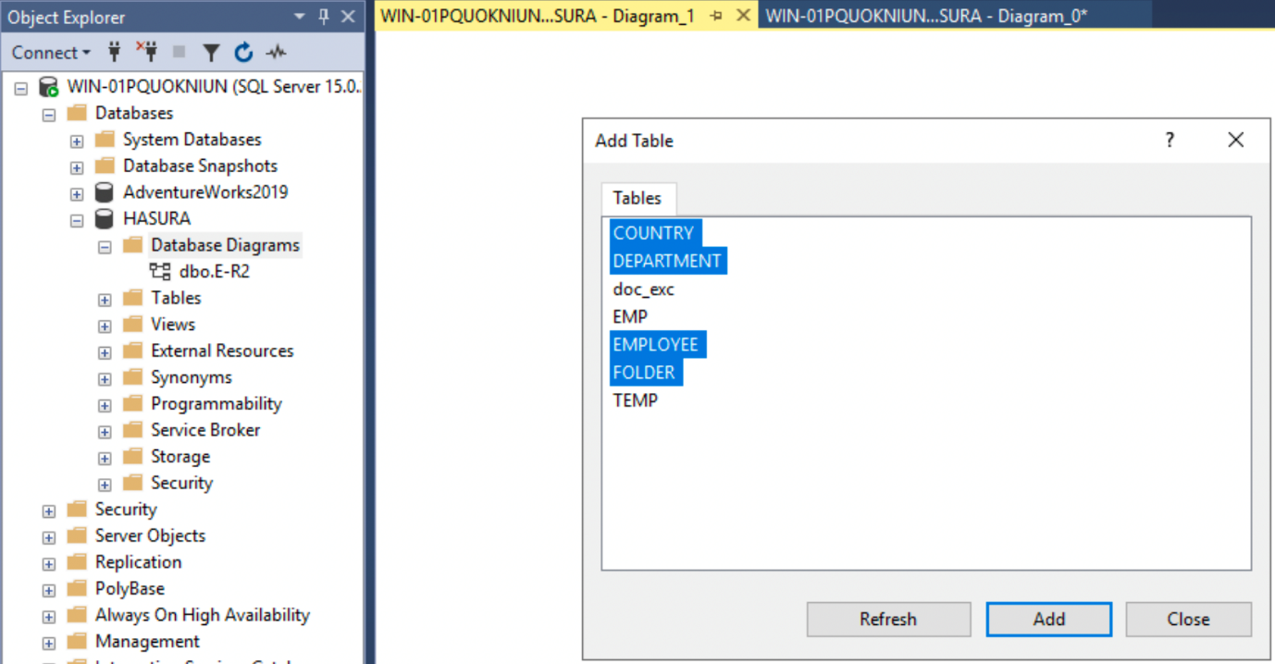

This generates the ER diagram.

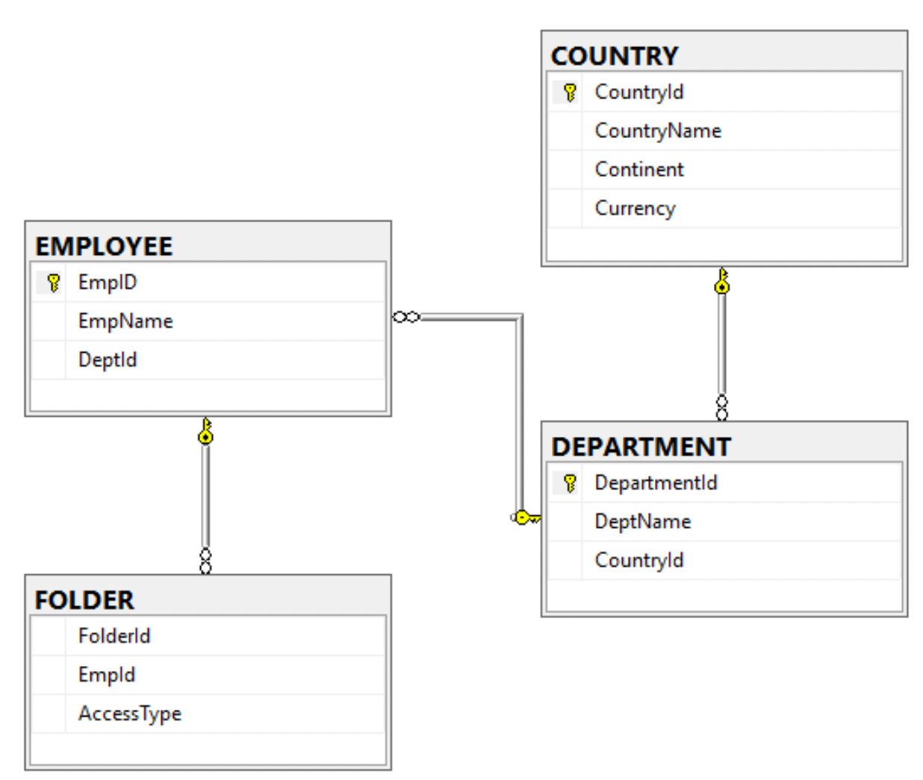

You can save and also copy the diagram to the clipboard.

Insert data

Copy

--5. Insert data into tables respecting the foreign key constraints

INSERT INTO COUNTRY VALUES('Germany', 'EUROPE', 'EUR');

INSERT INTO COUNTRY VALUES('London', 'UK', 'GBP');

INSERT INTO COUNTRY VALUES('India', 'ASIA', 'INR');

INSERT INTO COUNTRY VALUES('California', 'USA', 'USD');

INSERT INTO DEPARTMENT VALUES (29, 'R&D', 2);

INSERT INTO DEPARTMENT VALUES (17, 'HR', 1);

INSERT INTO DEPARTMENT VALUES (9, 'Finance', 3);

INSERT INTO DEPARTMENT VALUES (4, 'Product', 4);

INSERT INTO EMPLOYEE VALUES (1, 'Zuckerberg', NULL);

INSERT INTO EMPLOYEE VALUES (3, 'Jobs', 17);

INSERT INTO EMPLOYEE VALUES (2, 'Turing', 9);

INSERT INTO EMPLOYEE VALUES (4, 'Musk', 29);

INSERT INTO EMPLOYEE VALUES (5, 'Tesla', 9);

INSERT INTO FOLDER VALUES(1, 1, 'Read');

INSERT INTO FOLDER VALUES(1, 1, 'Write');

INSERT INTO FOLDER VALUES(1, 4, 'Read');

INSERT INTO FOLDER VALUES(1, 3, 'Read');

INSERT INTO FOLDER VALUES(2, 4, 'Read');

INSERT INTO FOLDER VALUES(2, 5, 'Write');

INSERT INTO FOLDER VALUES(3, null, null);

Retrieve data from E-R modeled tables

Copy

--Retrieve only those employees that belong to a department and are assigned permissions on the folders

SELECT f.FolderId, f.AccessType, e.EmpName, d.DeptName, c.CountryName, c.Continent

FROM EMPLOYEE e

INNER JOIN DEPARTMENT d

ON e.DeptId=d.DepartmentId

INNER JOIN COUNTRY c

ON c.CountryId=d.CountryId

INNER JOIN FOLDER f

ON f.EmpId=e.EmpId;

